**Atrayee Pathak**

**Sap id - 500105632**

**Lab Exercise 1– Install Terraform on Windows**

Installing Terraform on Windows requires you to download the correct Terraform package, unpack, and execute it via the [CLI](https://phoenixnap.com/glossary/common-language-infrastructure). Follow the instructions below to ensure you do not miss any steps.

**Download Terraform File for Windows**

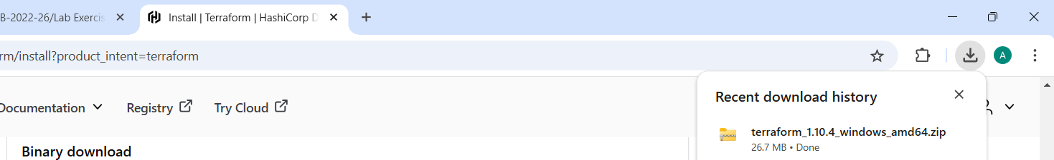

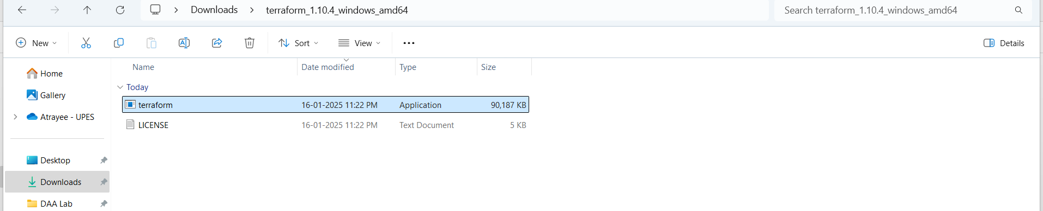

**Add Terraform Path to System Environment Variables**

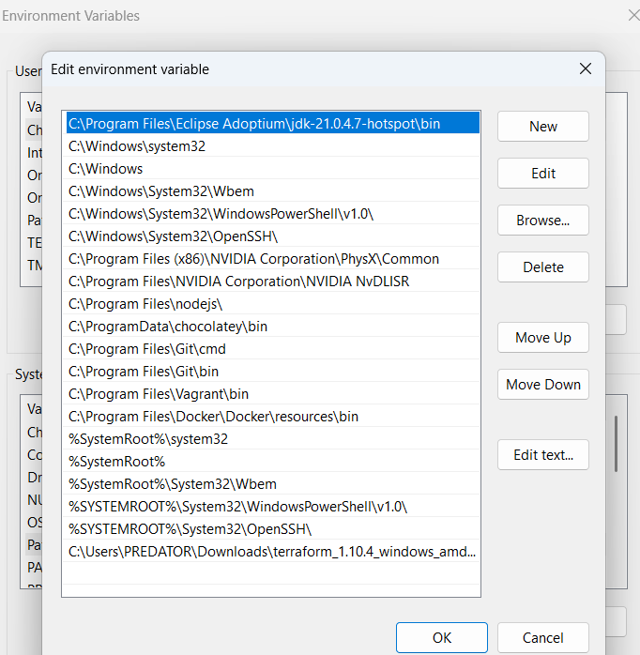

**Verify Windows Terraform Installation**

